Assignment 2 – Priority Queues, Huffman Trees

COIS 2020

Konrad Bartlett 0580964

Benjamin Keith 0623484

2018 – 11 – 06

Documentation:

Program menu:

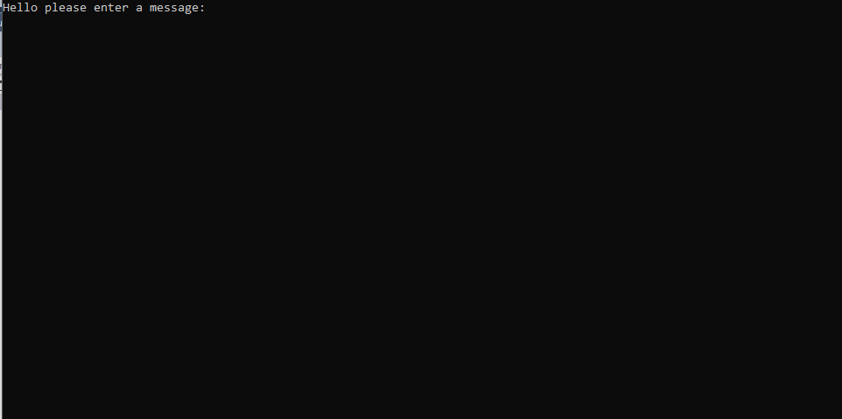

Single character

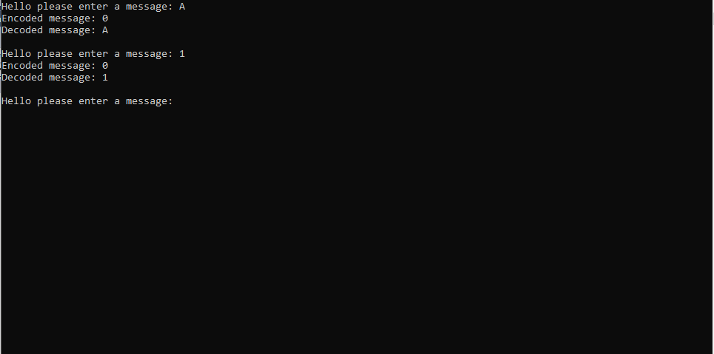

Multiple characters:

